

USER GUIDE

SIC ASSEMBLER & SIMULATOR

developed by-

BISHAL ROY (301510501001)

SUFI AFROZA NASRIN (301510501002)

MD DANISH (001410501067)

SIDHARTH KUMAR (001410501056)

**CONTENTS**

* INTRODUCTION
* REQUIREMENTS
* INSTRUCTION IMPLEMENTED
* HOW TO OPEN AND RUN PROGRAM
* HOW IT ACTUALLY WORKS
* GUI DESCRIPTION
* SAMPLE PROGRAMS
* INTRODUCTION

SIC is a hypothetical computer that has been carefully designed to include the hardware features most often found on real machines, while avoiding unusual or irrelevant complexities. This approach provides the reader with starting point from which to begin the design of system software for a new or unfamiliar computer.

So, we have developed SIC assembler and simulator in our system programming lab.

* REQUIREMENTS
* The code is written in C++. So, C++ compiler is needed.
* For handling the graphical user interface Qt application should be installed.
* INSTRUCTION IMPLEMENTED:

LDA, LDX, STA, STX

ADD, SUB, MUL

TIX, JEQ, JLT, JGT

The above instructions of SIC are implemented. But we have written some extra functions for string manipulation and memory handling. These instructions are-

LDS, CMPS, READ, READMEM, WRITE, WRITEMEM, STAM, STXM

* HOW TO OPEN AND RUN PROGRAM

1. Write any SIC program and save it as .txt file inside your project.

2. Click on Qt creator. Then screen will appear given below:

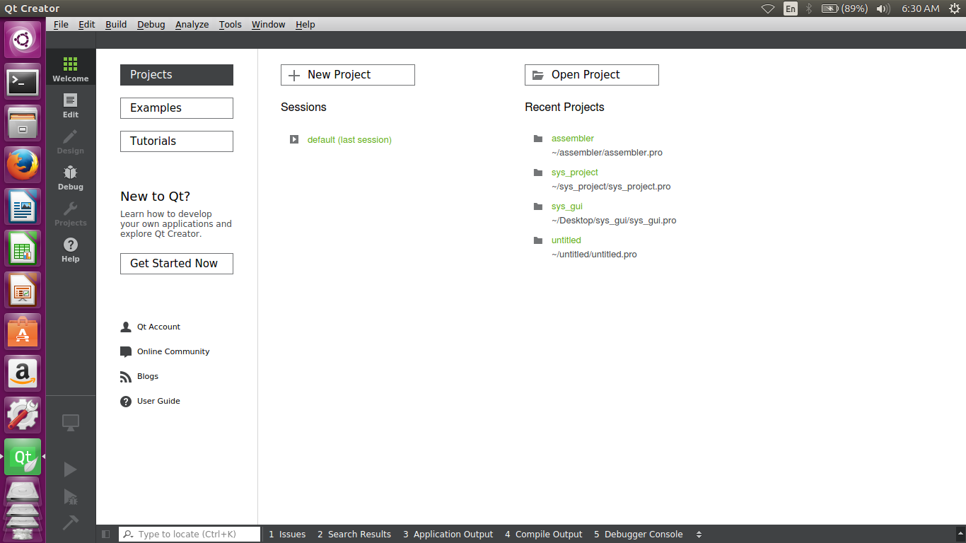

3. Select the project and open that. Then the screen will appear given below:

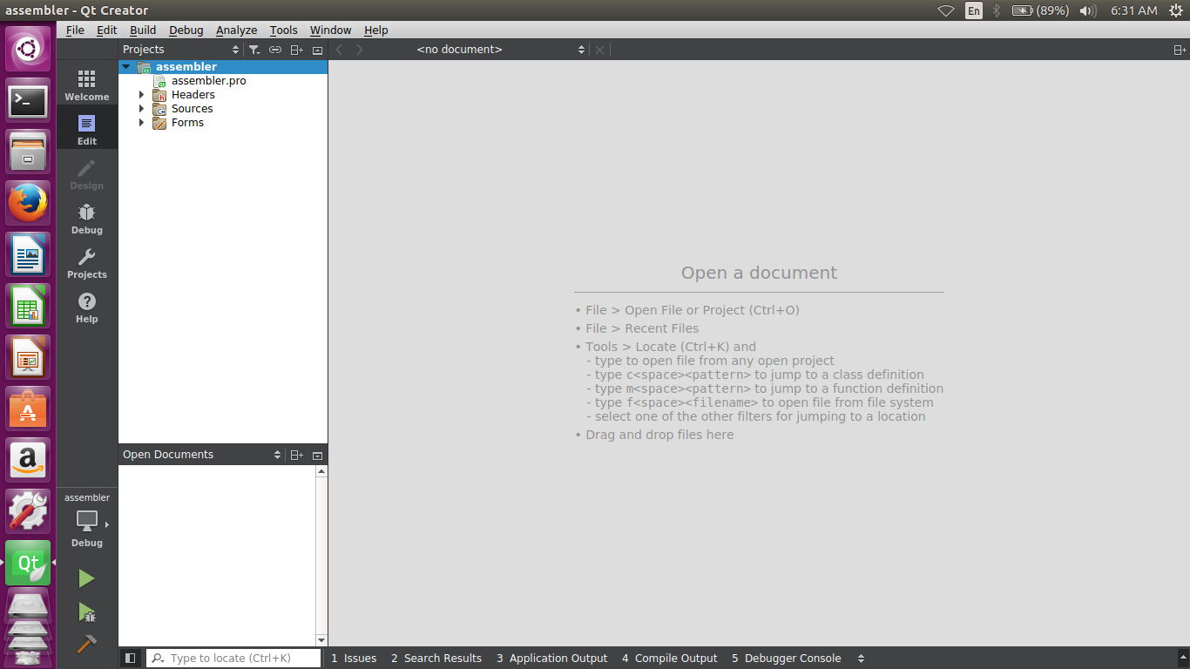

4. Then click on forms option and the screen given below will appear:

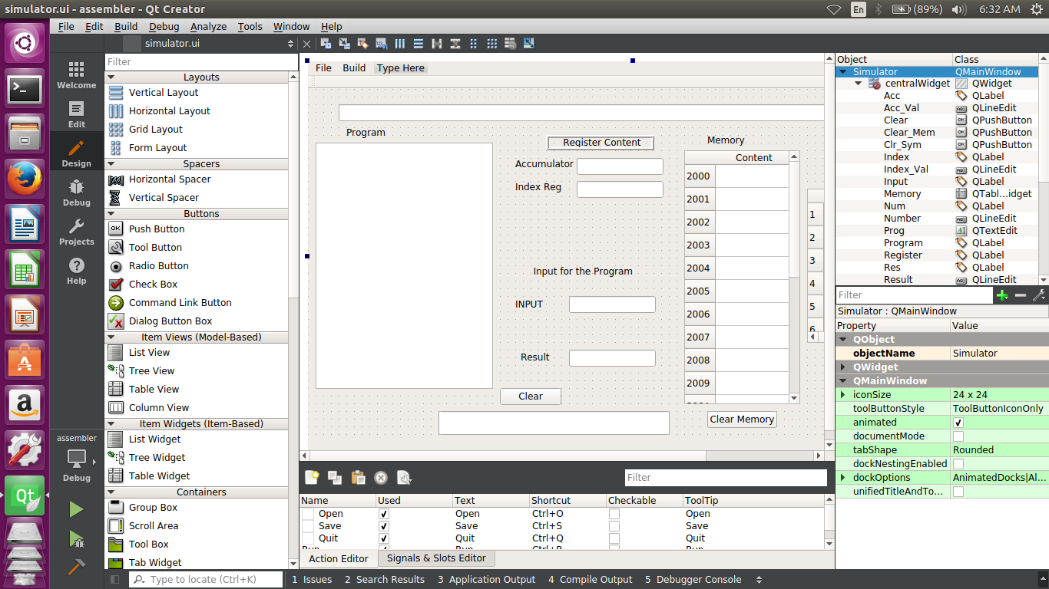

5. Now click on run. Then the graphical user interface will appear. User can run their program easily in GUI. The interface is given below:

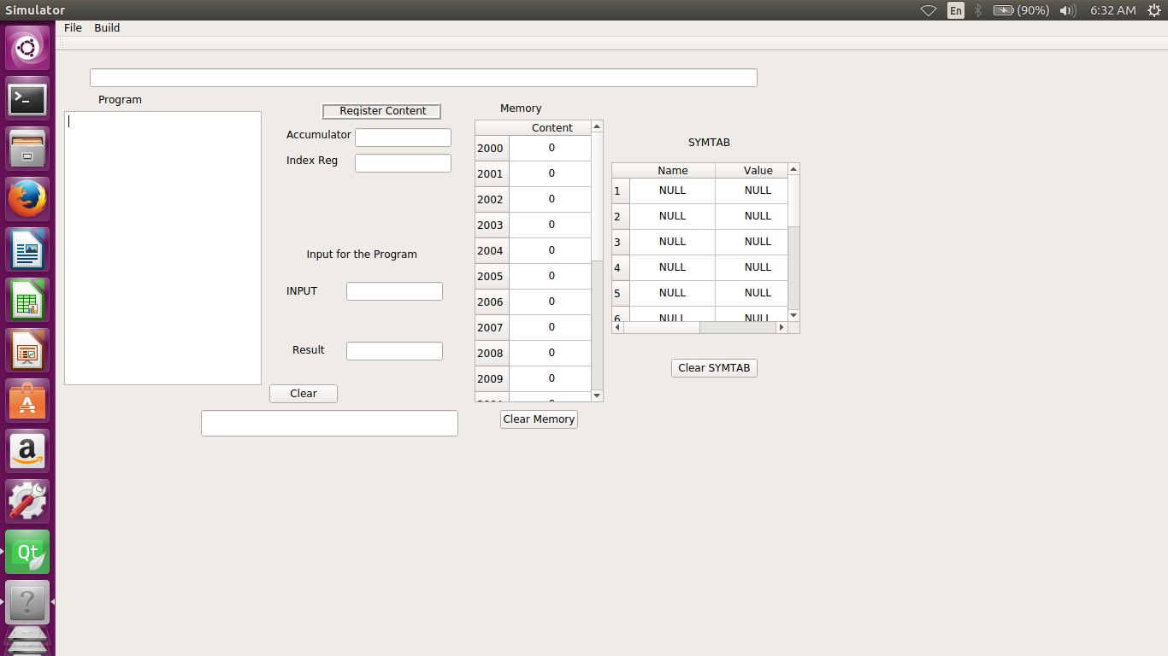

6. Go to file now and browse your SIC source code and then go to build option to run your program.

* HOW IT ACTUALLY WORKS?

Basically, we have implemented a two-pass assembler.

In pass 1, we are taking the source code as file. Then, all instructions are read line by line. We are parsing all lines to get the label, opcode, and operand part separately.

We are creating a symbol table which will be used in pass2.

The symbol table includes the name and value for each label in the source program.

In pass2, all data values are generated defined by BYTE, WORD and program executes.

* GUI DESCRIPTION

The Graphical User Interface (GUI) is a created in Qt creator and the user interface consists of all the entities required for the execution of SIC programs in the Assembler Simulator.

* It consists of a large text box portion which will contain the program. User can load program in the box by using action button “**OPEN**” in the “File” Menu in the menu bar. Also user can write any program in the specified box and save it any required location using “**SAVE**” button in the “File” Menu.
* At the top there is a title box which contains the path of the program that is currently in execution.
* There are two text boxes Acc_Val and Index_Val for showing the values of the Accumulator and Index register respectively.
* A tableWidget **Memory** is used to store the contents in the memory and that value can be used for different operation.
* A tableWidget **SYMTAB** is used to show the contents of the Symbol Table that are updated after the execution of the program.
* There are two text boxes for **Input** and **Result** that shows the input on which program has worked and the result that the program has generated.
* There are three PushButtons **Clear**, **Clear Memory** and **Clear SYMTAB** for clearing the contents of program, registers and the input ad result boxes; for clearing **Memory** and for clearing the **SYMTAB** respectively.
* At the top, in the MenuBar UI has a **BUILD** menu which contains the actionButton **RUN** that is used to build and run the program loaded in the program textBox. The Run button does all the functionality of executing the program.
* SAMPLE PROGRAMS

1. TO FIND FACTORIAL OF A NUMBER

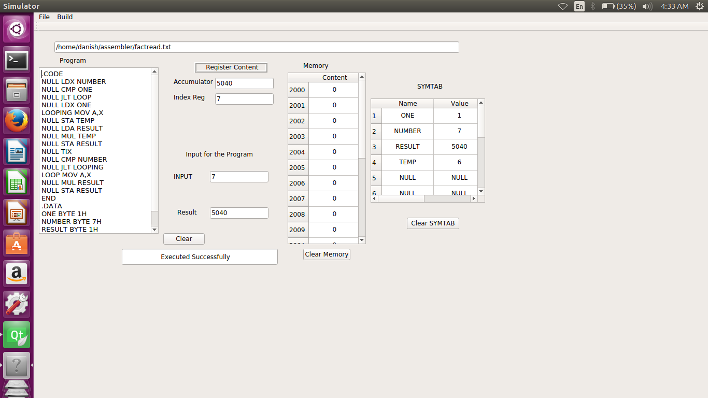

1. TO CREATE FIBONACCI SERIES

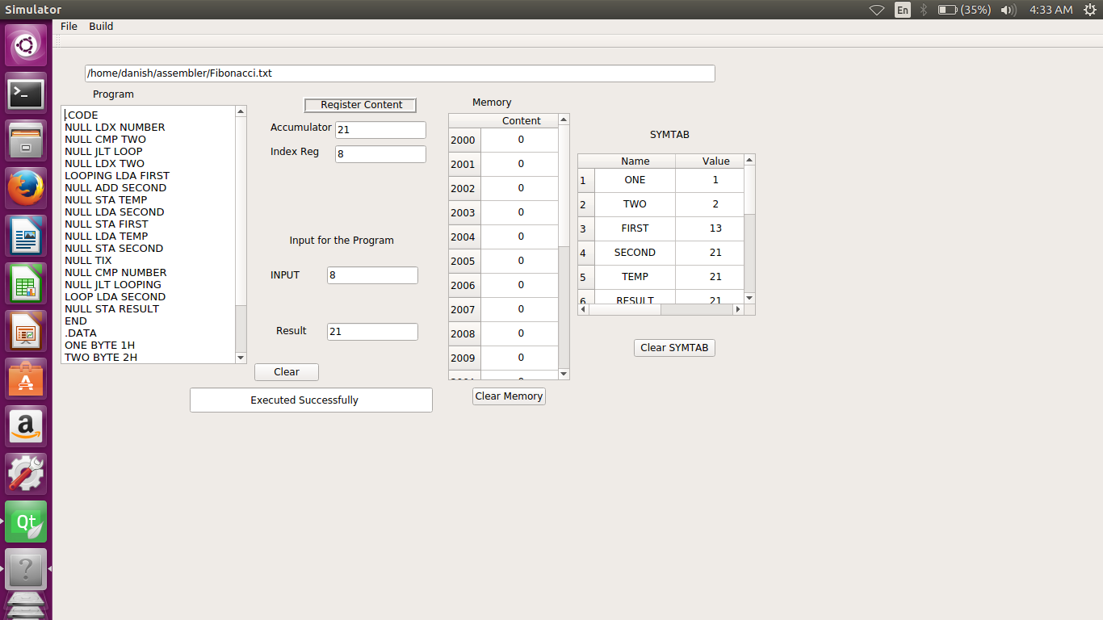

1. TO FIND SUBSTRING USING LINEAR SEARCH

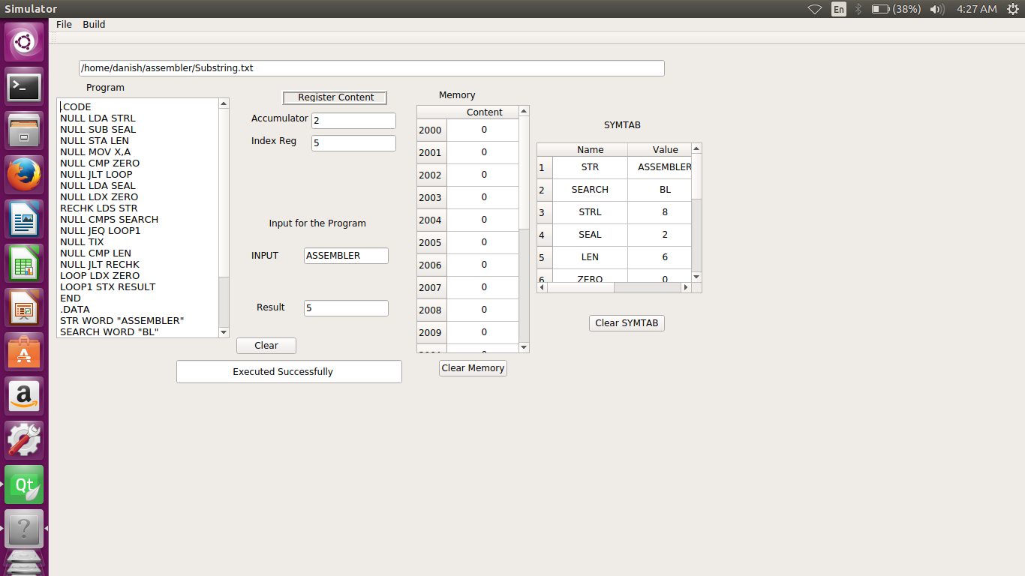

1. TO PERFORM SORTING

A>BEFORE SORTING

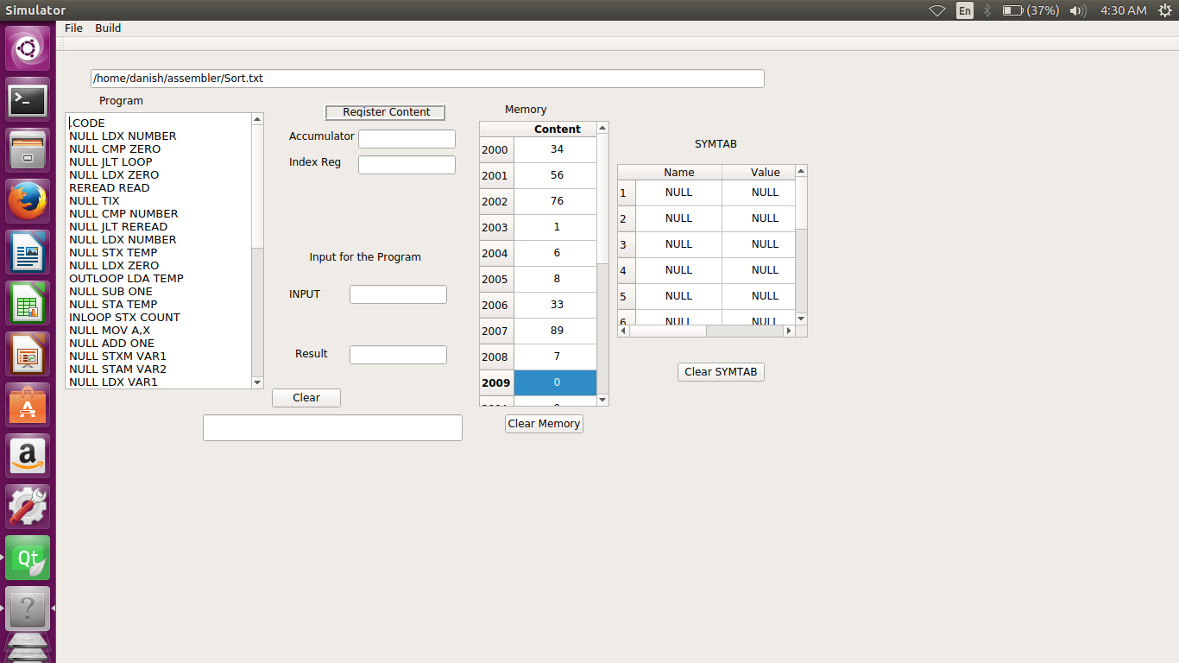

B>AFTER SORTING

